In a hospital ward

https://esol.britishcouncil.org/content/learners/skills/speaking/hospital-ward

At the dentist’s Office

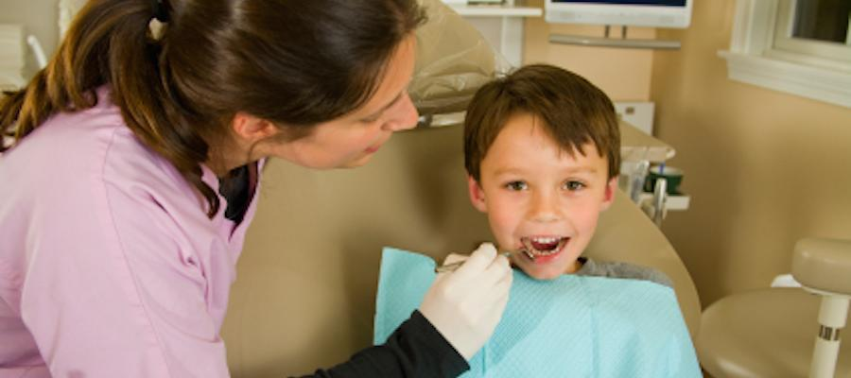
https://esol.britishcouncil.org/content/learners/skills/speaking/dentist%E2%80%99s

A Winter Scene

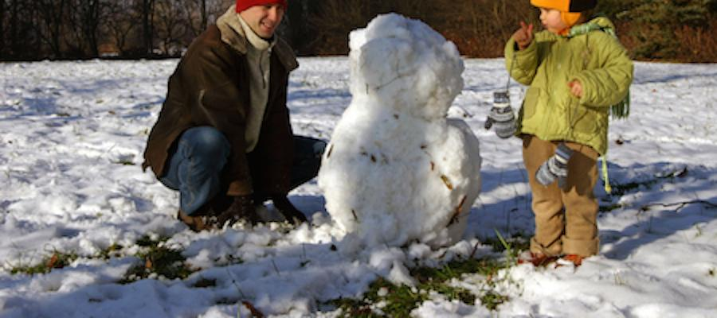
https://esol.britishcouncil.org/content/learners/skills/speaking/describing-winter-scene

A Family Scene

https://esol.britishcouncil.org/content/learners/skills/speaking/describing-picture-family-scene

Moving

https://esol.britishcouncil.org/content/learners/skills/speaking/short-presentation-housing

Sports

https://esol.britishcouncil.org/content/learners/skills/speaking/giving-short-presentation-sports

The school run

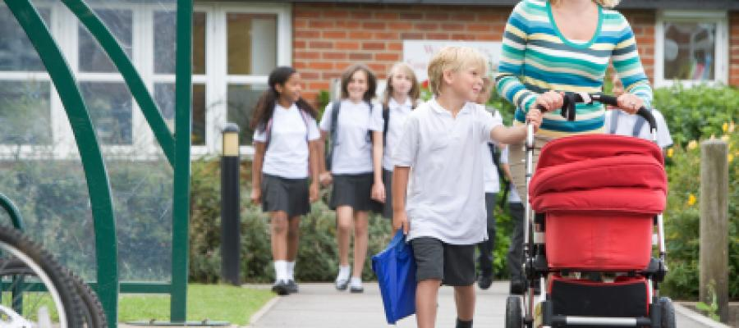
https://esol.britishcouncil.org/content/learners/skills/speaking/school-run

At work

https://esol.britishcouncil.org/content/learners/skills/speaking/work

A market stall

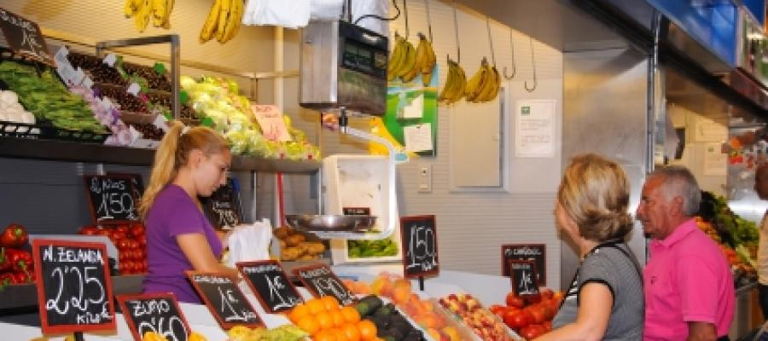
https://esol.britishcouncil.org/content/learners/skills/speaking/describing-picture-market-stall

Relaxing in the park
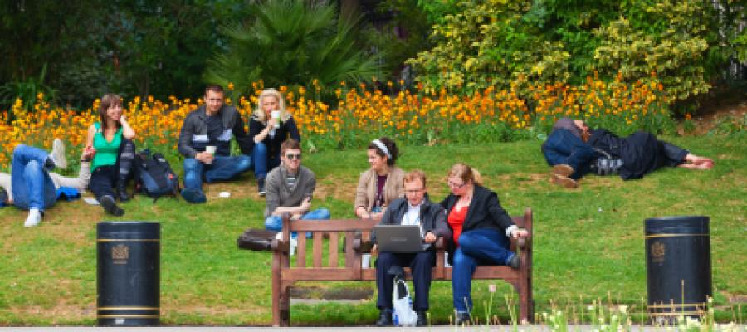
https://esol.britishcouncil.org/content/learners/skills/speaking/relaxing-park

Waiting in a queue
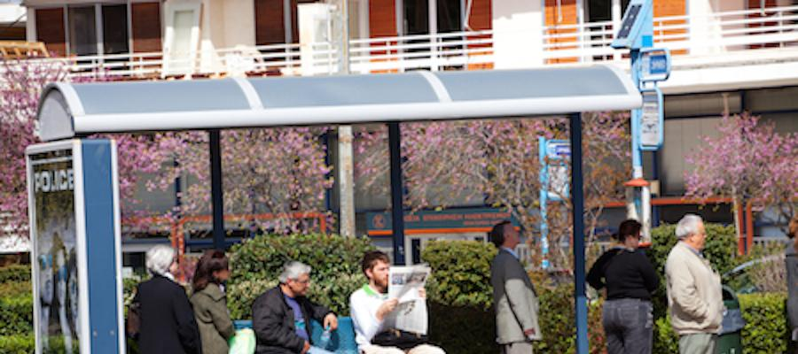
https://esol.britishcouncil.org/content/learners/skills/speaking/waiting-queue

Reading a personal story aloud
https://esol.britishcouncil.org/content/learners/skills/speaking/reading-personal-story-aloud

Reading directions aloud
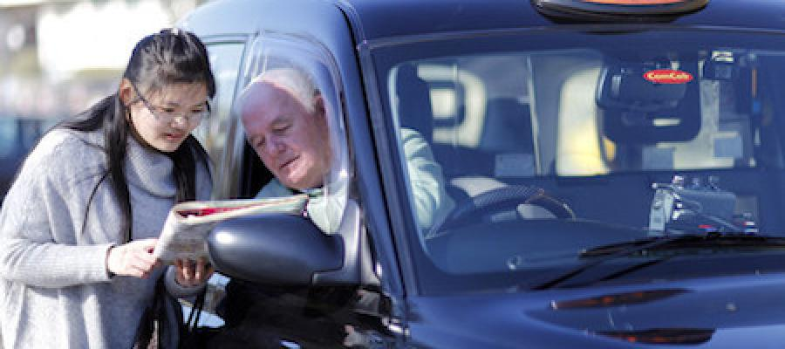
https://esol.britishcouncil.org/content/learners/skills/speaking/reading-directions-aloud

Reading a recipe aloud

https://esol.britishcouncil.org/content/learners/skills/speaking/reading-recipe-aloud

Food in a fridge

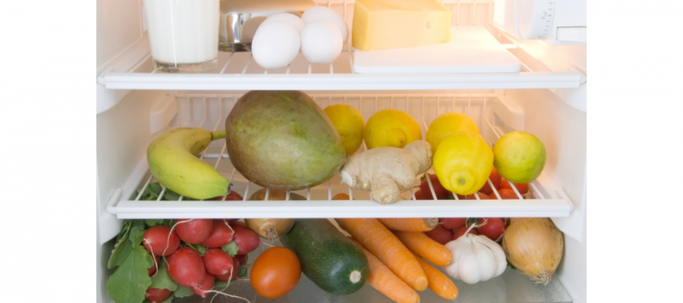
https://esol.britishcouncil.org/content/learners/skills/speaking/food-fridge

The Living Room

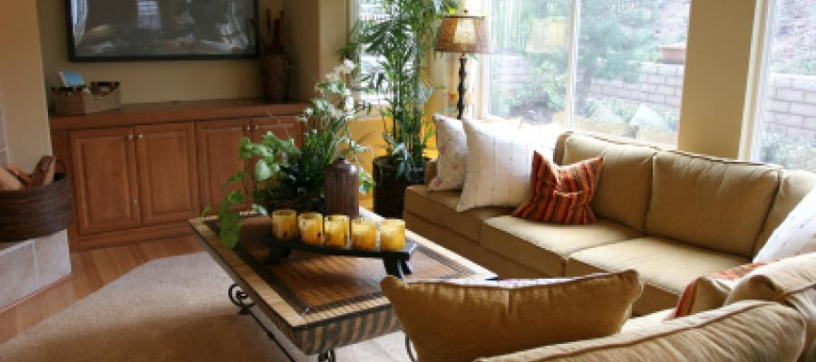
https://esol.britishcouncil.org/content/learners/skills/speaking/describing-image-house

Money
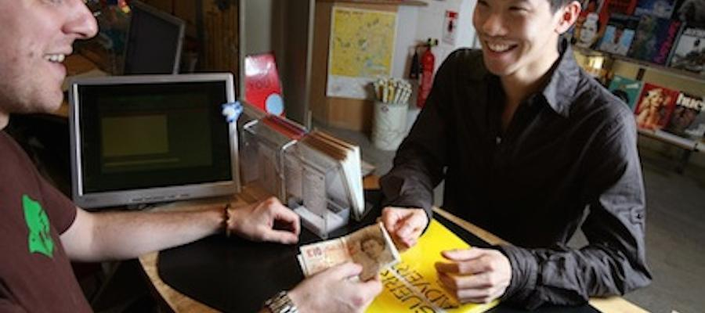
https://esol.britishcouncil.org/content/learners/skills/speaking/giving-short-presentation-money

Shopping on a market

https://esol.britishcouncil.org/content/learners/skills/speaking/giving-short-presentation-shopping

