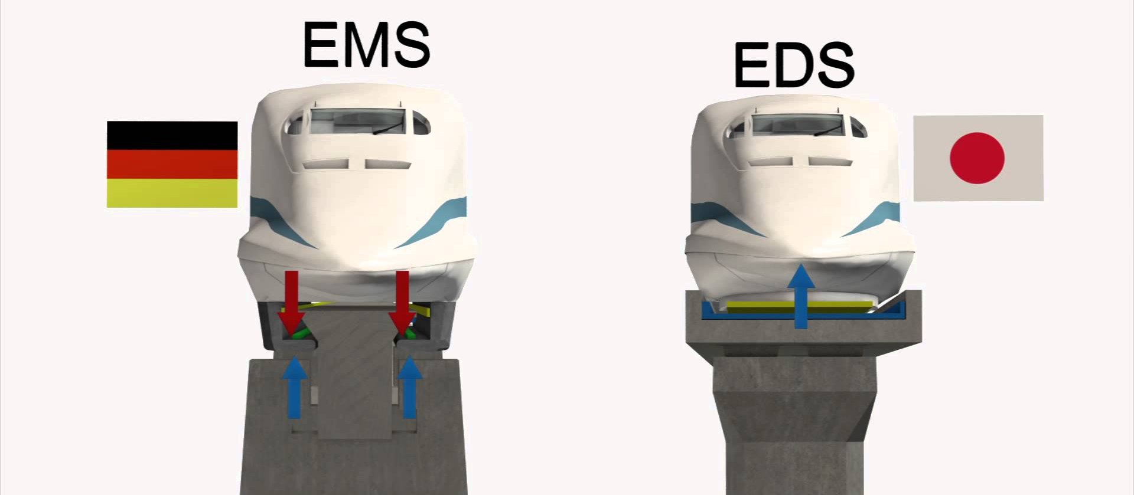

Electromagnetic Suspension (EMS) | Electrodynamic Suspension (EDS)
Country: Germany | Country: Japan
Type of Magnets: standard magnets | Type of Magnets: super-cooled, superconducted electromagnets
Locomotion:  No landing gear (cars without tires) | Locomotion:  Works only on minimum speed of about 30 km/h (19 mph)  cars with landing gear (rubber tires) used for liftoff speed of about 62 miles/h (100 km/h).
System:  unstable nature of electromagnetic attraction | System:  Stable system  two systems – repulsive and attractive
Magnetic Field:  magnets are wrapped around tracks,  low magnetic field inside (no magnetic shield) | Magnetic Field:  Magnets on car body,  high magnetic field (cars have to be shielded from the magnetic field: harms pacemaker, storage items))
Saftey: emergency battery power supply that prevents the train from hitting the guideway; | Safety: magnets can conduct electricity even after the power supply has been shut off
Levitation height: approximately 0.59 in (15 millimetres | Levitation height: 4 inches (10cm)
Speed: 500 km/h (310 mph) | Speed: 581 km/h (361 mph)
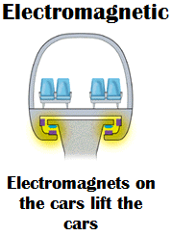 | 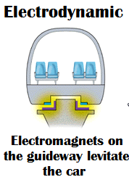
Track: Beam | Track: Panel

